Vivechana Bhat
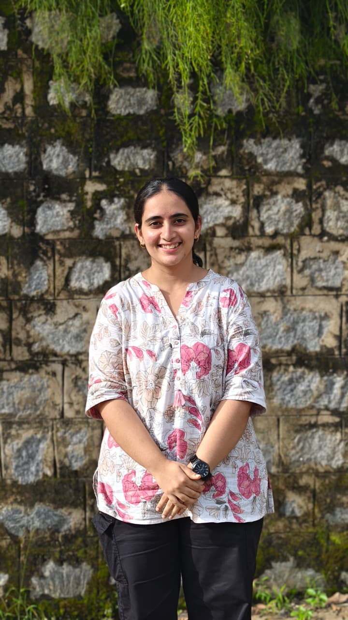
Vivechana comes from the beautiful coastal city of Mangalore, she completed her schooling at Kendriya Vidyalaya and pursued her college education at Sharada P U College. She's currently in her fourth year of Biomedical Science, exploring the fascinating world of cancer biology through her research on the differential expression of lncRNAs in 2D monolayer and 3D tumeroid models in lung cancer progression.
Beyond academics, she's an avid reader, enjoys drawing, dancing and can happily spend hours watching movies and dramas. She's curious about science, passionate about creativity, and always up for a little fun along the way.

Jalisha Riyona D Silva
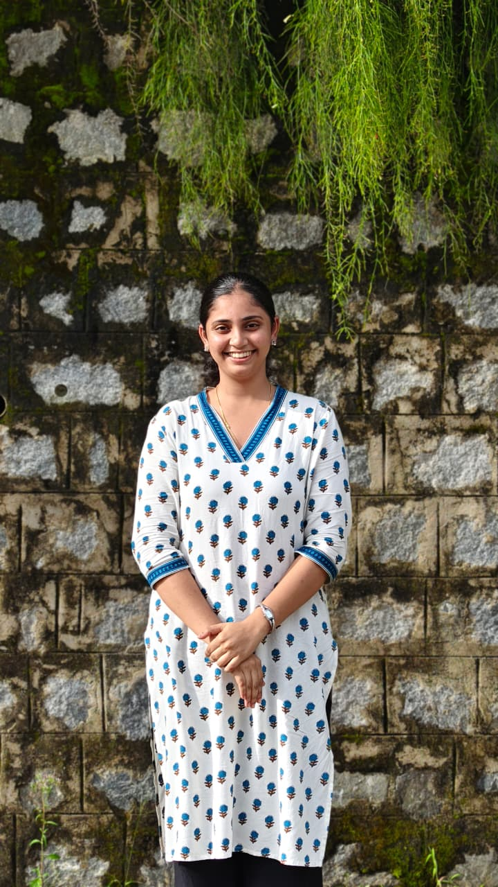
Jalisha Riyona Dsilva hails from Karnataka, India. She completed her schooling at St. Thomas Higher Primary School, Byndoor, followed by her PU at Expert PU College, Mangalore. She is currently pursuing her final year of B.Sc. Biomedical Sciences at Nitte University Centre for Science Education and Research, Mangalore.
Driven by curiosity, creativity, and a love for science, she is currently working on the evaluation of differential expression of lncRNAs in 2D monolayer and 3D tumoroid models during liver cancer progression.For her, science is interesting because it is something she understands, questions, and genuinely enjoys learning about. Research keeps her curious, while painting brings out her creative side. She believes there is something beautiful about both science and art—science helps her understand how things work, while painting gives her a way to express her creativity.
With a curious mind and a creative heart, Jalisha hopes to keep learning, exploring new possibilities, and turning her interest in science into meaningful discoveries.
Pratihiksha Poojary
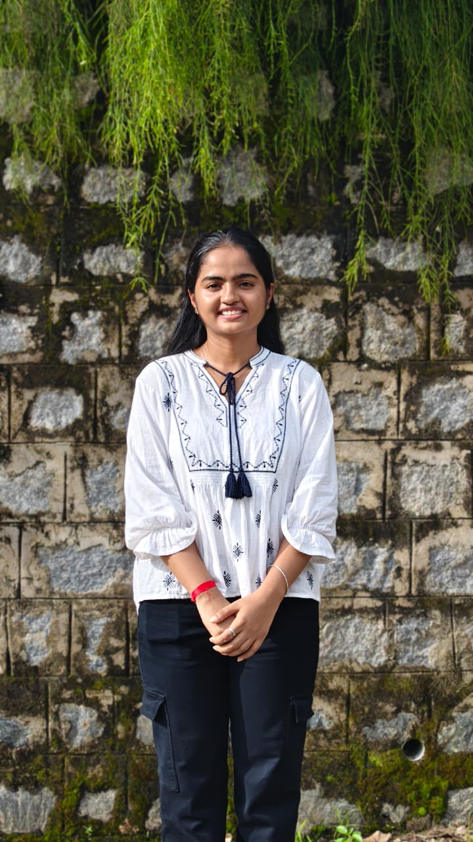
Prathiksha is a fourth-year BSc Biomedical Science student at NUCSER. Here interests lie in molecular biology, cancer biology and microbiology.
Her current research takes her into the world lncRNAs, where she is exploring the differential expression of lncRNAs in 2D monolayers and 3D tumoroids in breast cancer progression.
When she's not thinking about cells and cancer pathways, she is usually lost in painting, crocheting, or a good movie. She finds joy in creating things with her hands, watching movies and occasionally stepping away from the microscope to simply enjoy the colourful side of life

Shanelle Leanne Colaco
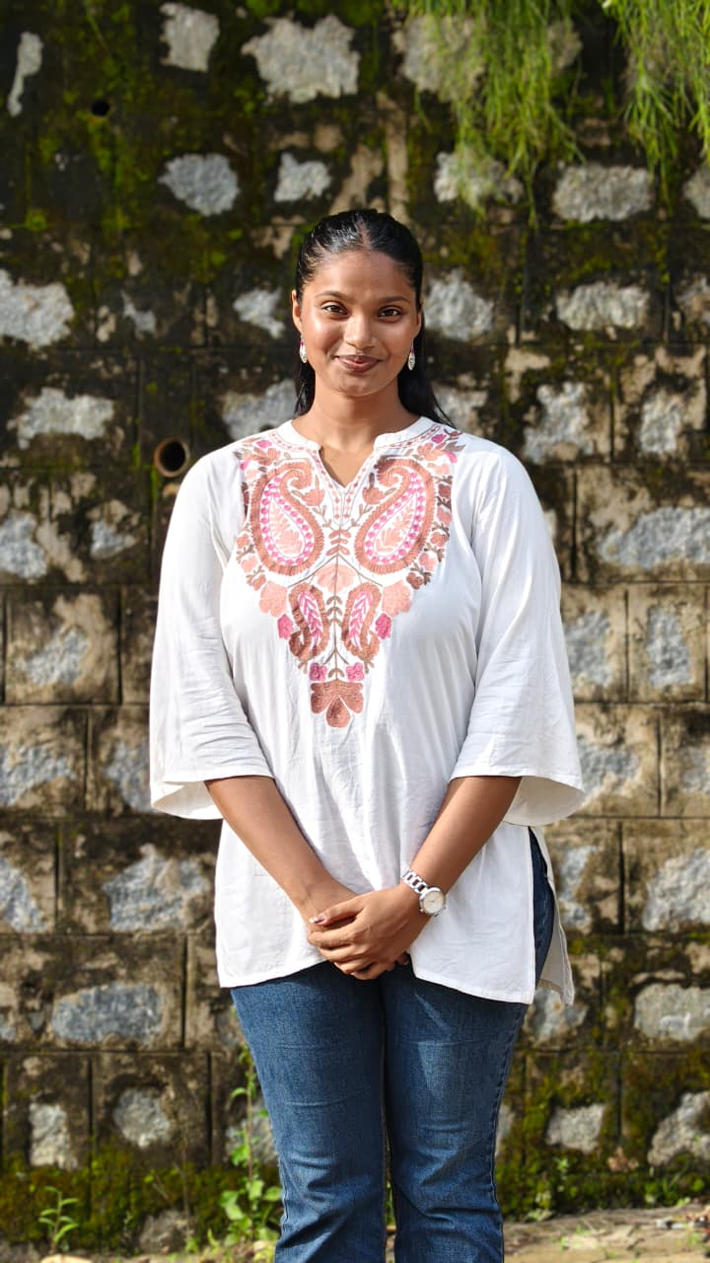
Shanelle is a third-year B.Sc. Biomedical Science student at NUCSER, originally from Goa. She is particularly interested in cancer biology, embryology, and nanotechnology, and enjoys exploring how these fields can come together to answer interesting questions in biomedical research.
Outside the lab, Shanelle is a huge fan of music and singing—if she weren’t a girl in STEM, she’d probably be chasing a career in singing! She loves baking, mountains, and discovering new experiences. And, most importantly, chai speaks to her the way a walk speaks to a dog.
She is always excited to learn something new, whether it’s happening under a microscope or completely outside the lab.
Sanjana Satyanarayan Naik
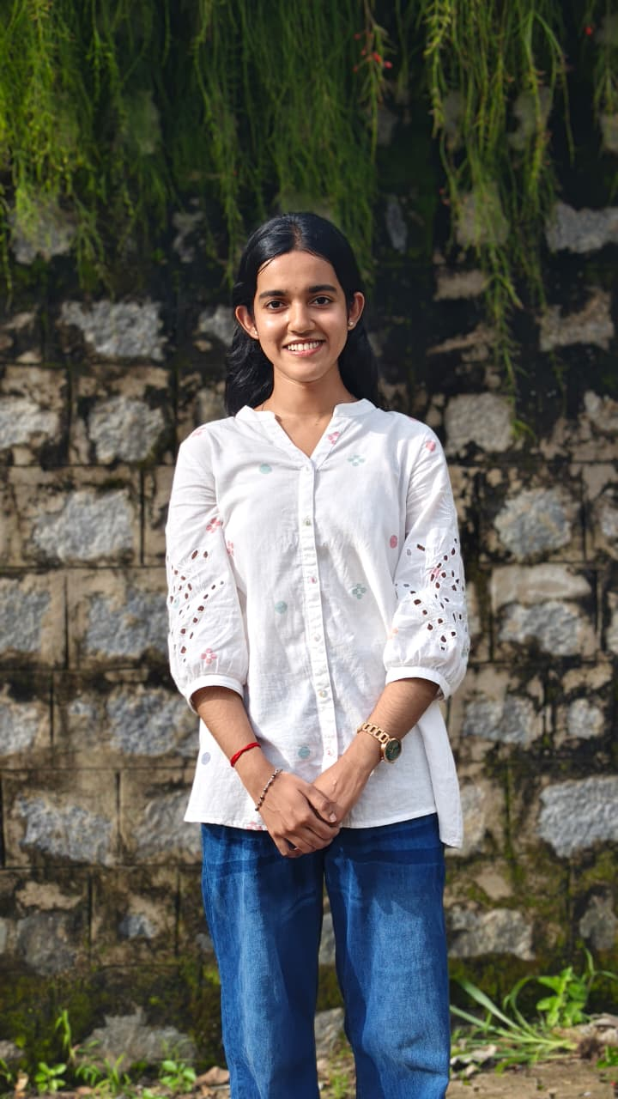
Sanjana Satyanarayan Naik is from Kumta, Karnataka. She completed her schooling at Gibb English Medium High School, followed by her pre-university education at HB PU College, Kumta. She is currently pursuing her final year of B.Sc. Biomedical Sciences (Honours) at Nitte University Centre for Science Education and Research, Mangalore.
With a keen interest in life sciences, she is currently working on the evaluation of differential expression of lncRNAs in 2D monolayer and 3D tumoroid models during lung cancer progression.
Beyond academics, she enjoys sketching, dancing, reading books, and listening to music. She also loves travelling. With a curious mind and a love for learning and exploring, she hopes to continue discovering new interests and opportunities along the way

Prerana H S

Hailing from Bengaluru, Prerana did her 10th grade at Vignan BoTree School and her 12th grade at Silver Oaks, Hyderabad, before moving into biomedical sciences. She’s currently a 4th-year BSc Biomedical Sciences (Hons) student at NITTE NUCSER, Mangalore.
Her project evaluates how lncRNA expression differs between 2D monolayer cultures and 3D tumoroid models in glioblastoma — work that looks at how the switch from flat, dish-grown cells to more tumor-like 3D structures changes the molecular signals driving cancer progression.
Outside the lab, she’s usually picking up a new dance step, rewatching an old classic, or getting lost in a song’s lyrics trying to read between the lines. When she needs to switch off entirely, it’s a bit of drawing or painting.

Teertha Surve
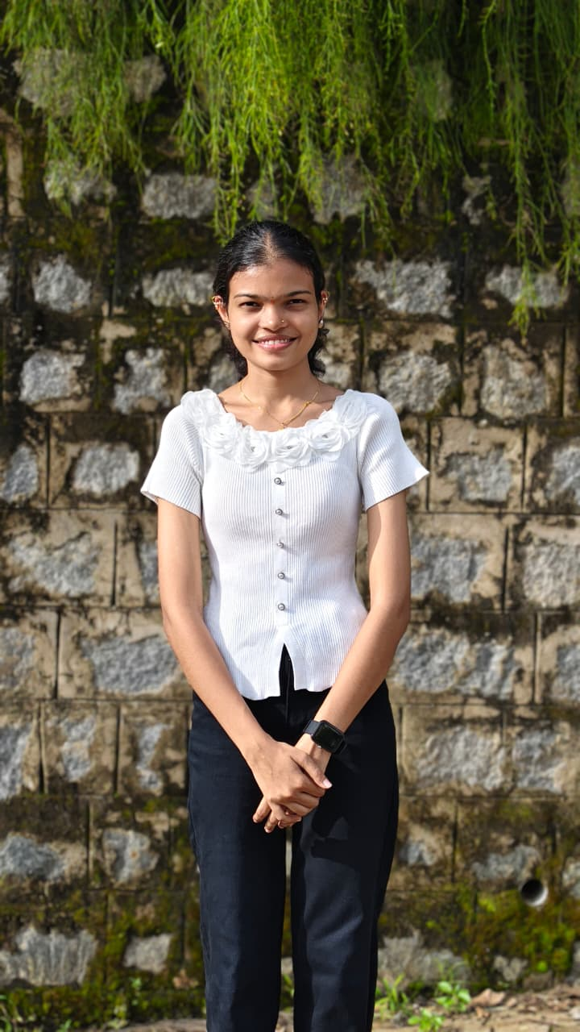

Teertha Santosh Surve is a second year MSc. Cancer Biology student at NUCSER. She is trying to starve breast Tumours of their blood supply. Her work centres on screening cyclic urea-based VEGFR2 inhibitors in breast cancer for their therapeutic potential, which basically means she is hunting for the molecule that says "no" to Tumour angiogenesis.
After labs, her evenings belong to paint, yarn and whatever dish she's craving for. On weekends, she treats a good series as a serious research topic.

Davika Cardoso
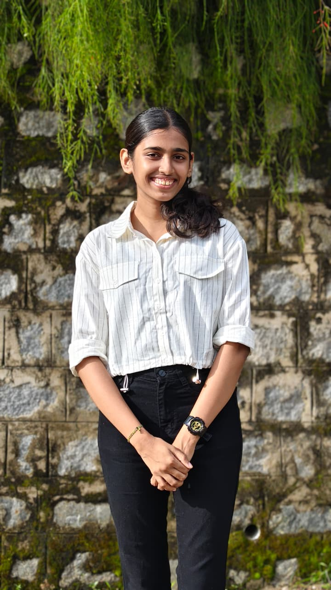
Davika is currently pursuing her Master’s in Cancer Biology and has a keen interest in understanding cancer and the factors that influence its progression. Her current project looks at how lncRNA MALAT1 responds to changes in the stiffness of the environment around cervical cancer cells and how this may affect their behaviour and progression.
Outside the lab, Davika enjoys painting, listening to music, and watching movies and series. She also enjoys cooking and baking, with pizza and tiramisu being two of her favourite things to make. She likes spending her free time being creative, trying new things, and relaxing with a good movie or some music.

P Siddhanth
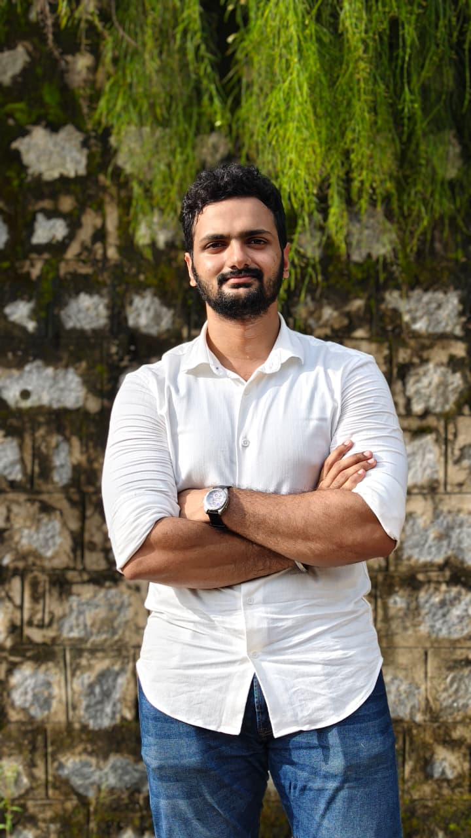
Originally from Chennai Tamil Nadu, Siddhanth had finished his undergraduate degree from Guru Nanak college chennai and currently pursues his postgraduate degree in M.sc. Biotechnology from Nitte deemed to university. He has a vibrant list of hobbies which include books, trekking, bike rides and fitness.
He is currently working on the project titled "Investigating the mechanosensory role of MALAT1 in 2D and 3D cell architectures in cervical cancer"

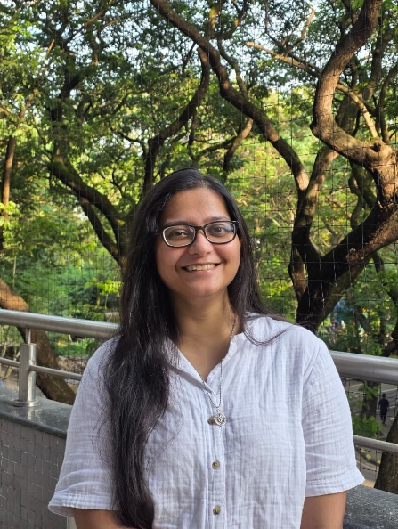
Animikha Paul

Coming from a family filled with biologists, her love for life sciences developed early. After spending her whole life in Kolkata and completing her Master’s in Biochemistry from Calcutta University, she moved to Mumbai to pursue her PhD at the Chemical Engineering department in IIT Bombay. Apart from having interest in understanding basics of cancer biology, she also enjoys playing football, creating art in the form of painting and jewelleries, trekking or simply looking at the night sky.

Ashish Soman
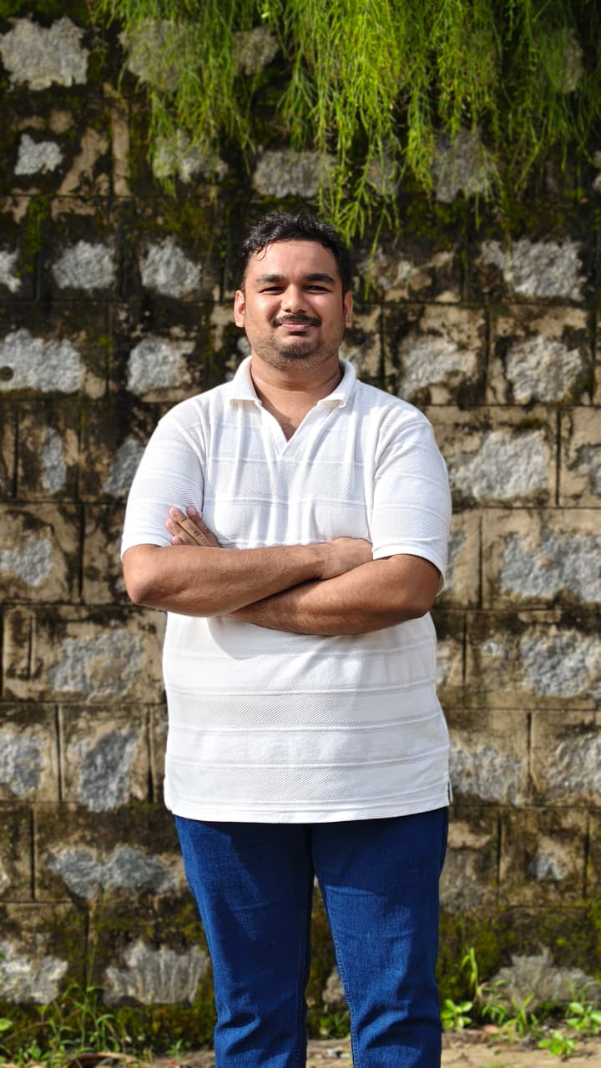
For Ashish, biology is less of a subject and more of a lifelong rabbit hole. Born and brought up in the beautiful Konkan region of Maharashtra, he studied Biotechnology for his graduation and Cancer Biology for his postgraduate degree. He is now a Project Associate at NUCSER, where he gets to spend his days doing what he enjoys most: asking questions about biology and occasionally getting lost in the answers.
His current work focuses on lncRNA profiling in a glioblastoma multicellular tumoroid model. His research interests include telomere biology, brain tumours, particularly glioblastoma, and long non-coding RNAs. He is fascinated by the tiny molecular details that can have surprisingly big consequences. In other words, give him a complicated biological question and there is a decent chance he will happily disappear into it for the next few hours.
When he is not in the lab, Ashish enjoys singing, listening to Hindustani classical music, and reading. He is also a proudly self-proclaimed biology nerd, which means there is always room for one more random biological fact in his head. He believes a good day can involve a fascinating research question, a great piece of music, and a book that makes him forget to check the time. And if a conversation somehow turns into biology, well, you have probably just found his favourite topic.

